KEY INSTANT RECALL FACTS (KIRFS) YEAR 2 AUTUMN 1 Home Learning
I know number bonds to 20.
Y2 children should now know number bonds to 10 off by heart. By the end of this half term, children should know the facts in the first 3 columns below. The aim is for them to recall these facts instantly. They should be able to work out other number facts within 20 like the ones shown in the final column.
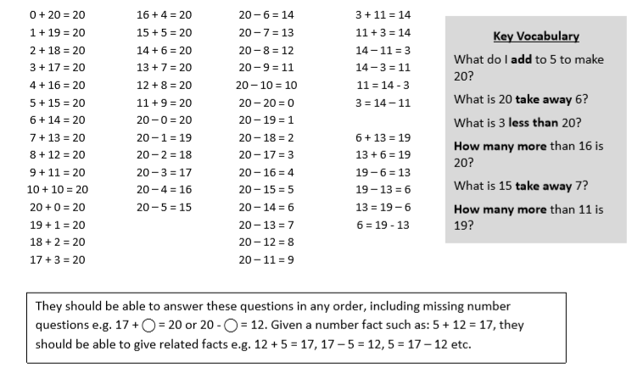

Top Tips
The secret to success is practising little and often. Use time wisely. Can you practise these KIRFs while walking to school or during a car journey? You don’t need to practise them all at once: perhaps you could have a fact of the day. If you would like more ideas, please speak to your child’s teacher.
Use practical resources – Make collections of 20 objects. Ask questions such as, “How many more conkers would I have left if I took away one?”
Online – This website is to practise counting up or down from a given number: https://uk.ixl.com/math/year-1/count-up-and-down-up-to-10
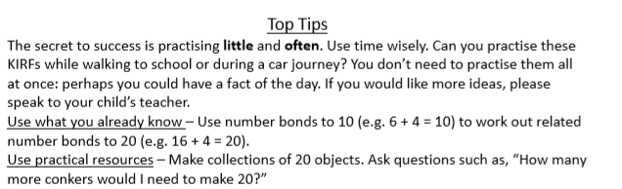

Make a Poster – Your child could make a poster showing the different ways of making 20.
Play games – you can practise (KIRFS) online http://www.conkermaths.org/cmweb.nsf/pages/kirfs.html

